

**Project Document**

**Name :MUGUNTHAN S**

**Register Number :720722106027**

**Department :ECE-A**

**Year :2 year**

**Project Title**

**DESIGN THINKING IN TWEETER**

**Template Name**

**PROCESS FLOW CHART**

**Problem Statement**

|  |  |  |  |  |
| --- | --- | --- | --- | --- |

**How might we develop an efficient and accurate sentiment analysis model for Twitter that automatically classifies tweets as positive, negative, or neutral?**

**Project description**

**DESIGN THINKING IN TWEETER**

**Tweeter is an audio equipment retailer that was founded in 1972 and primarily operates in the United States. It specializes in selling a wide range of audio products, including speakers, home theater systems, headphones, and other accessories. Tweeter was once a prominent player in the consumer electronics retail industry but faced financial challenges and eventually filed for bankruptcy in 2007. The company's stores were subsequently closed, and its assets were liquidated. While Tweeter no longer operates as a retail chain, it remains a recognizable brand in the audio industry.**

**Worked Template with explanation**

**Could you provide more context or specify what you mean by "tweeter"? Are you referring to the social media platform Twitter, or perhaps something else?**

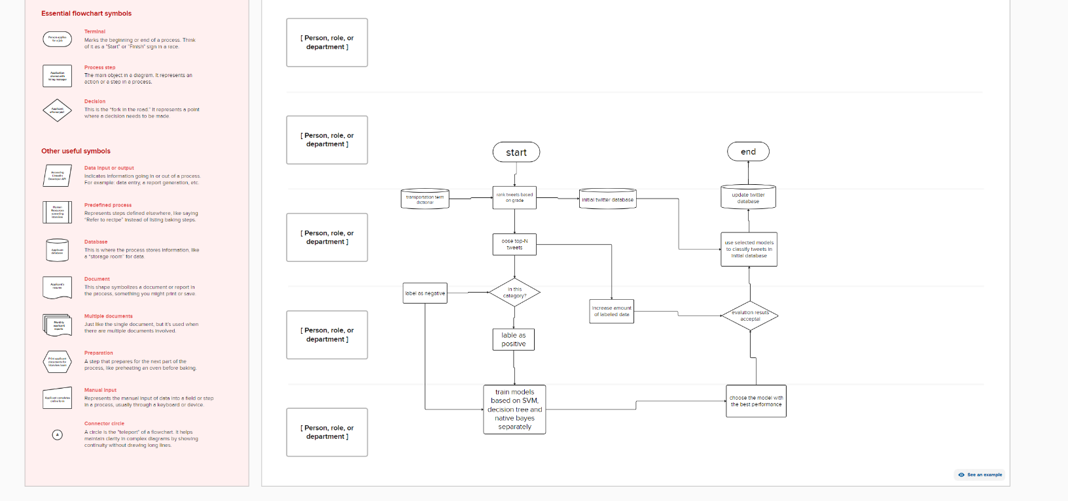

**GitHub Link:**

[**https://github.com/Mugunthan9247/IBM.git**](https://github.com/Mugunthan9247/IBM.git)